Requirement Analysis Phase
Data Flow Diagrams and User Stories – UCAB Cab Booking Application
Date | 23 June 2026
Team ID
Project Name | UCAB – Smart Cab Booking Application
Maximum Marks | 4 Marks

Data Flow Diagrams
A Data Flow Diagram (DFD) shows how data moves through the UCAB system – what enters and leaves the system, which processes transform it, and where it is stored. The diagrams below represent the UCAB system at two levels of detail.

Level 0 – Context Diagram
The context diagram shows UCAB as a single process and how it exchanges data with its three external entities: the User, the Driver, and the Administrator.
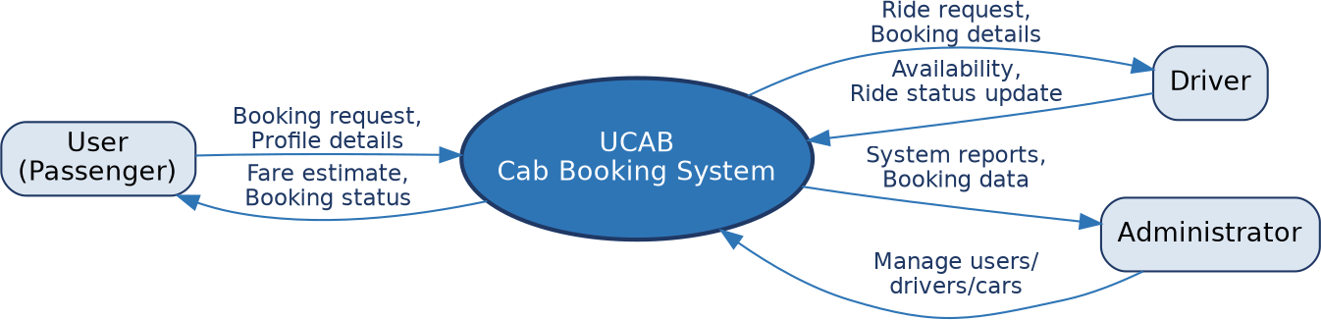

Level 1 – Detailed DFD
The Level 1 diagram breaks the system down into its four core processes – authentication, cab search and fare estimation, booking and ride management, and admin management – along with the data stores each process reads from or writes to.
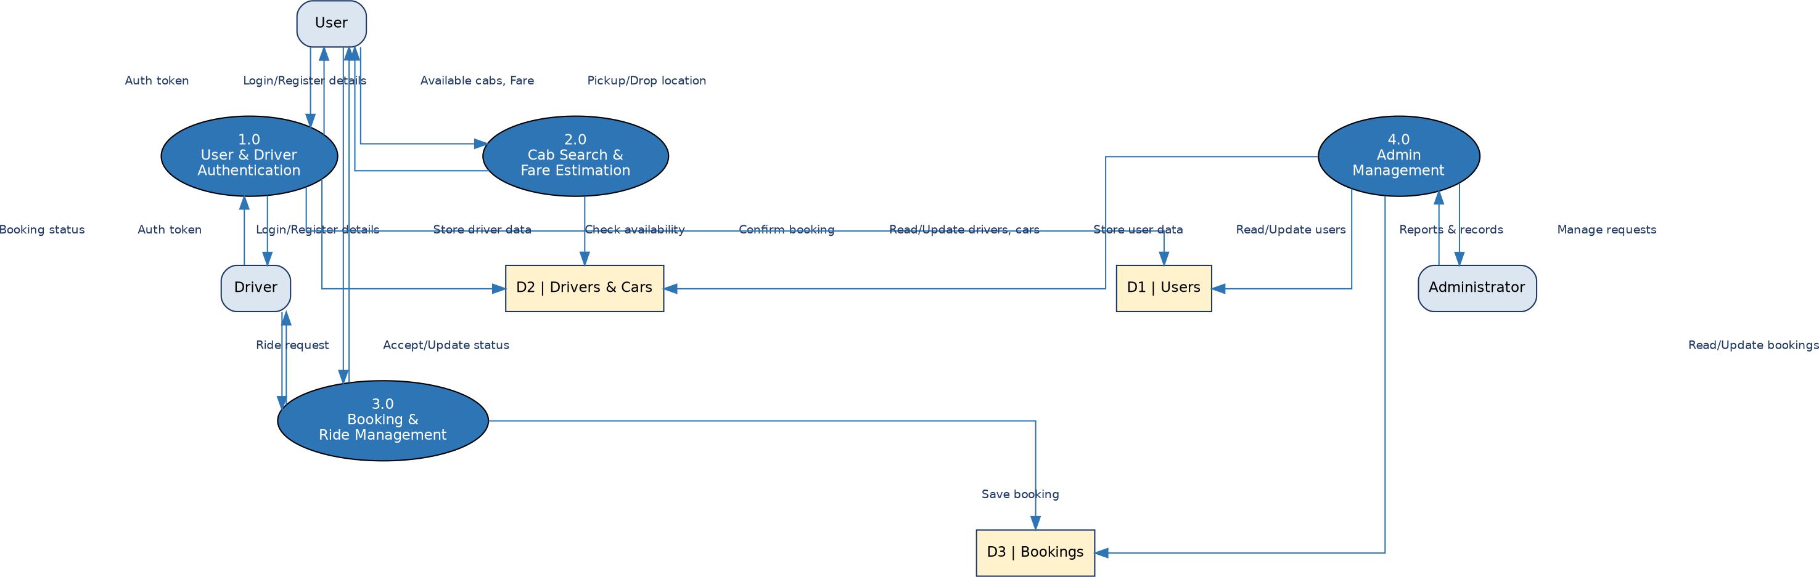

User Stories
The table below lists the user stories defined for each type of UCAB user, along with the associated acceptance criteria, priority, and planned release.
User Type | Functional Requirement (Epic) | User Story No. | User Story / Task | Acceptance Criteria | Priority | Release
Customer (Passenger) | Registration | USN-1 | As a user, I can register by entering my name, email, phone number, and password. | I can create an account and access my dashboard | High | Sprint-1
 |  | USN-2 | As a user, I receive a confirmation message after successful registration. | I receive confirmation and can log in | Medium | Sprint-1
 | Login | USN-3 | As a user, I can log in using my registered email and password. | I can access my dashboard after logging in | High | Sprint-1
 | Cab Booking | USN-4 | As a user, I can search for available cabs by entering pickup and drop locations. | I can view a list of nearby available cabs | High | Sprint-1
 |  | USN-5 | As a user, I can view the estimated fare before confirming my booking. | The fare estimate is displayed before confirmation | High | Sprint-1
 |  | USN-6 | As a user, I can confirm a booking by selecting a cab and driver. | I receive a booking confirmation with driver details | High | Sprint-2
 | Booking Management | USN-7 | As a user, I can view my current and past booking history. | I can see all my bookings along with their status | Medium | Sprint-2
 |  | USN-8 | As a user, I can log out of the application securely. | I am logged out and redirected to the login page | Low | Sprint-1
Driver | Registration & Login | USN-9 | As a driver, I can register by providing my personal and vehicle details. | I can create a driver account | High | Sprint-1
 |  | USN-10 | As a driver, I can log in using my registered credentials. | I can access my driver dashboard | High | Sprint-1
 | Ride Management | USN-11 | As a driver, I can view and accept incoming ride requests. | I can accept a request and view trip details | High | Sprint-2
 |  | USN-12 | As a driver, I can update my availability status. | My status is reflected when users search for cabs | Medium | Sprint-2
 |  | USN-13 | As a driver, I can update the ride status as I complete a trip. | The user sees the updated ride status in real time | Medium | Sprint-2
Administrator | User & Driver Management | USN-14 | As an admin, I can view, add, update, or remove users and drivers. | Changes are reflected correctly in system records | High | Sprint-3
 | Car Management | USN-15 | As an admin, I can manage car details and availability status. | Car records are updated correctly across the system | Medium | Sprint-3
 | Booking Monitoring | USN-16 | As an admin, I can monitor all bookings across the system. | I can view booking details and status for every user | High | Sprint-3

